Capstone Project-Battle of Neighborhoods:

### 

### Is Ahmedabad City similar to Toronto city?

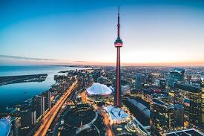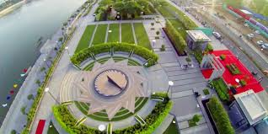

Mohit Rajput

Table of Contents

Introduction 3

Objective(Business Problem) 4

Data……………………………………………………………………………………….5

Methodology 8

Results 11

Discussion ……………………………………………………………………………13

Conclusion……………………………………………………………………………17

Introduction

Ahmedabad is located in Gujarat, India. It plays a major role in Country’s economy. Ahmedabad is known for his business capital and Restaurant businesses. Toronto is the capital city of the province of Ontario and the largest city in Canada. Toronto is a Centre of business, finance, arts, and culture, and is recognized as one of the most multicultural and cosmopolitan cities in the world. Both cities are well known in Malaysia, and become the top choice for local and foreign communities.

**Brief information about both cities:  
AHMEDABAD**: Ahmadabad has emerged as an important economic and industrial hub in India. It is the second largest producer of cotton in India, and its stock exchange is the country's second oldest. Cricket is a popular sport in Ahmadabad, which houses the 54,000-seat Sardar Patel Stadium. The effects of liberalization of the Indian economy have energized the city's economy towards tertiary sector activities such as commerce, communication and construction. Ahmadabad's increasing population has resulted in an increase in the construction and housing industries resulting in recent development of skyscrapers.  
(source: https://en.wikipedia.org/wiki/Ahmedabad)

**toronto**: Toronto is a prominent Centre for music, theatre, motion picture production, and television production, and is home to the headquarters of Canada's major national broadcast networks and media outlets. Its varied cultural institutions, which include numerous museums and galleries, festivals and public events, entertainment districts, national historic sites, and sports activities, attract over 25 million tourists each year. Toronto is known for its many skyscrapers and high-rise buildings, in particular the tallest free-standing structure in the Western Hemisphere, the CN Tower.  
(source: https://en.wikipedia.org/wiki/Toronto)

**Objective (Business Problem)**

In this project, we will study in details the area and doing classification using Foursquare data and machine learning segmentation and clustering. The aim of this project is to segment areas of Ahmedabad and Toronto based on the most common places captured from Foursquare.

Using segmentation and clustering, we hope we can determine:

* The similarity or dissimilarity of both cities
* Classification of area located inside the city whether it is residential, tourism places, or others
* Find an optimal location for establish a business
* Restaurant food popularity
* Identify optimal place for Bus station, Railway station or Airport

Data

### The data we used in this project is in .csv format. Hence, there are no accurate data is available for Ahmedabad City, so all data is collected by manually and Wikipedia. For, Toronto City we used Wikipedia’s List_of_postal_codes_of_Canada__M.html and Toronto geospatial data.

The data acquired from Wikipedia pages and restructure to csv file for easier manipulation and reading. Both Ahmedabad and Toronto city necessary data files uploaded to my GitHub link for references. In, this data each row is referred by neighborhood.

### Links to websites which are used to get data:

* https://en.wikipedia.org/wiki/Category:Neighbourhoods_in_Ahmedabad
* https://www.latlong.net/
* https://www.census2011.co.in/census/city/314-ahmedabad.html

### Link to the data files are:

* https://github.com/mohit-n-rajput/Coursera_Capstone/blob/master/data/Geospatial_Coordinates.csv
* <https://github.com/mohit-n-rajput/Coursera_Capstone/blob/master/data/List_of_postal_codes_of_Canada__M.html>
* https://github.com/mohit-n-rajput/Coursera_Capstone/blob/master/data/Geospatial_Coordinates.csv

### Another aspect to consider for this project is the Foursquare data. I believe that the data as good as provided, meaning although we are using Foursquare data for segmentation and clustering, the amount and accuracy of data captured can't 100% determine correct classification in real world. Also, there are no accurate data about Ahmedabad neighborhood, it's all collected by me.

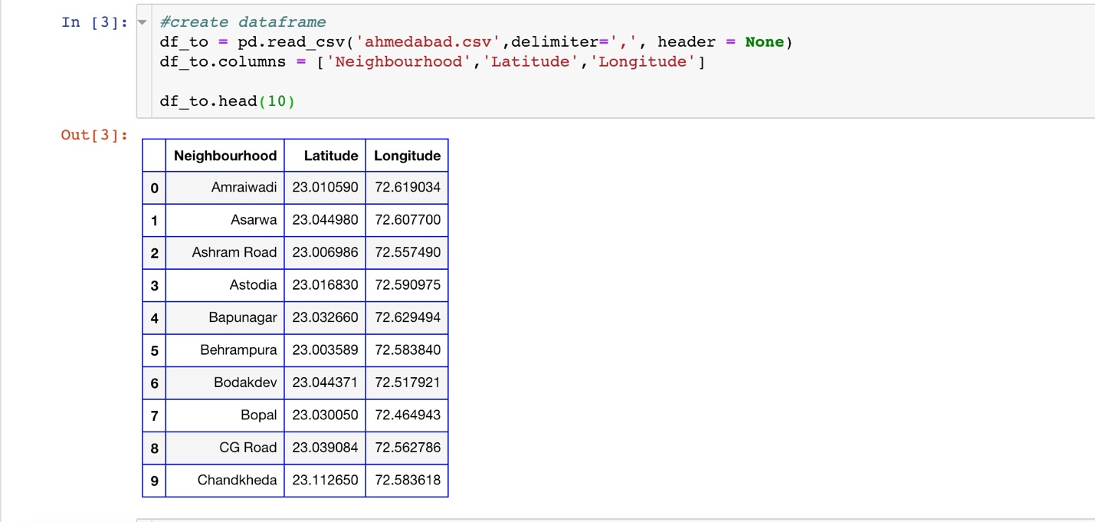**Ahmedabad City Neighborhood Data:**

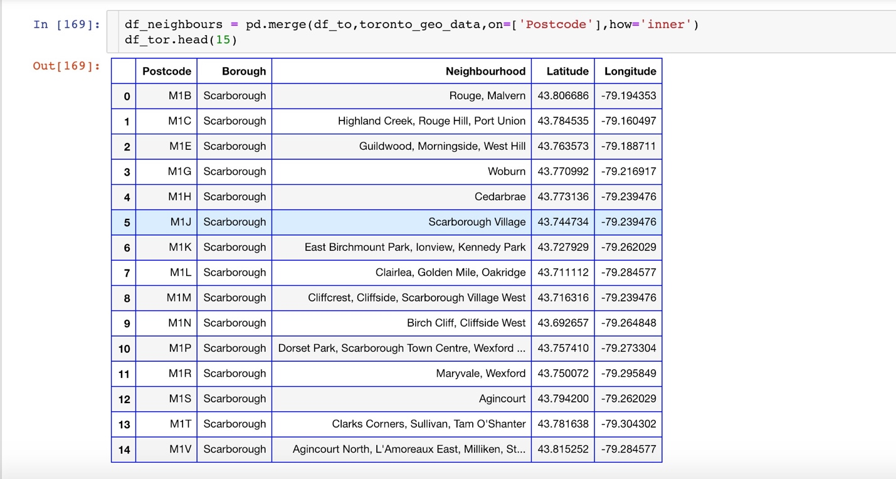**Toronto City Neighborhood Data:**

**City data accessible through the FourSquare API:**

This data will produce the following deliverables.

* A list of all neighborhoods in Toronto, Ahmedabad with a different venues
* A list of the top ten venues in each neighborhood
* A ranking of all neighborhoods with a specific venue based on Review

**Methodology**

In this project, we will use the basic methodology of data science methodology.

After the Business Problem Definition, Best analytic approach is chosen.

**After that process of data analysis is done:**

* + - Data requirements
    - Data collection
    - Data processing
    - Data cleaning
    - Exploratory data analysis
    - Modeling and algorithms
    - Data product

**Data requirements, collection, preprocessing:**

In this step data about like neighborhood, and location of neighbor of Ahmedabad and Toronto Cities are collected, after that NaN values are removed and data is preprocessed.

**After Data Preprocessing:**

* We have done convert addresses into their equivalent latitude and longitude values, and neighborhoods name.
* Then we will use the Foursquare API to explore neighborhoods in both cities, Ahmedabad and html
* After that, explore function to get the most common venue categories in each neighborhood, and then use this feature to group the neighborhoods into clusters

**Modeling and algorithms:**

**K-means clustering algorithm** will be use to complete this task. And also, **the Folium library to visualize the neighborhoods** in Ahmedabad and Toronto and their emerging clusters.

Here K-Means Clustering Intuition are Shown:

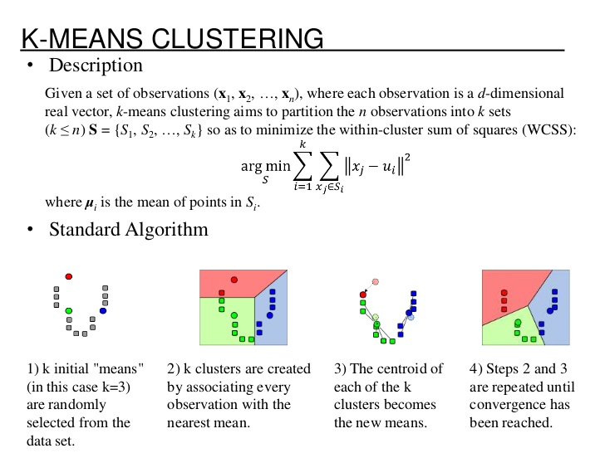

Data Product:

As a data product we have clusters after apply the algorithm, this cluster are very helpful to comparing cities.

Results

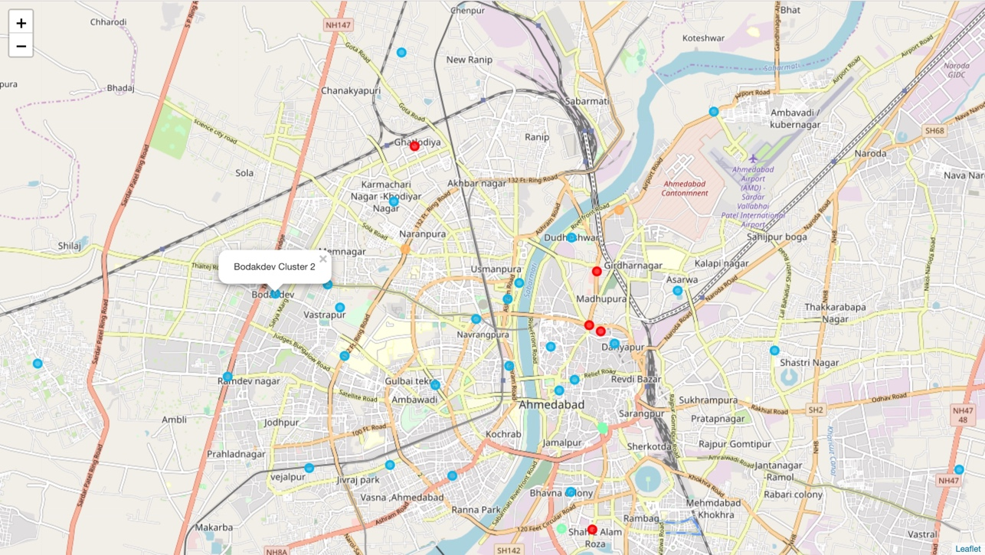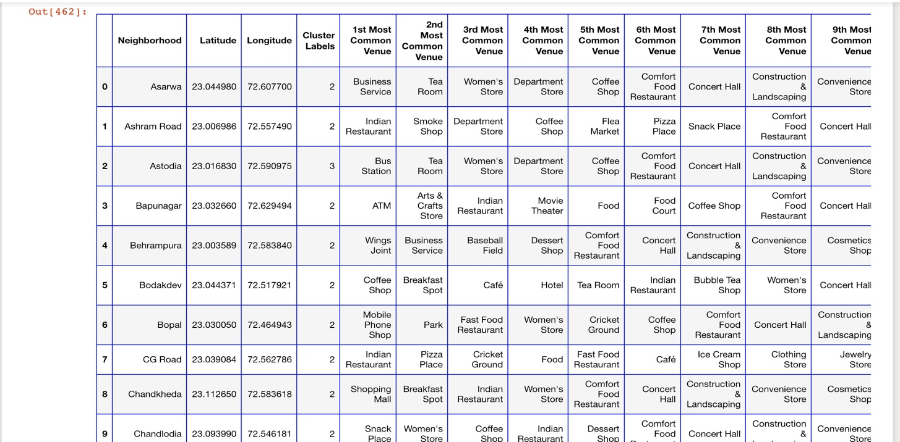Ahmedabad City Popular Neighborhood’s place dataframe and Clusters:

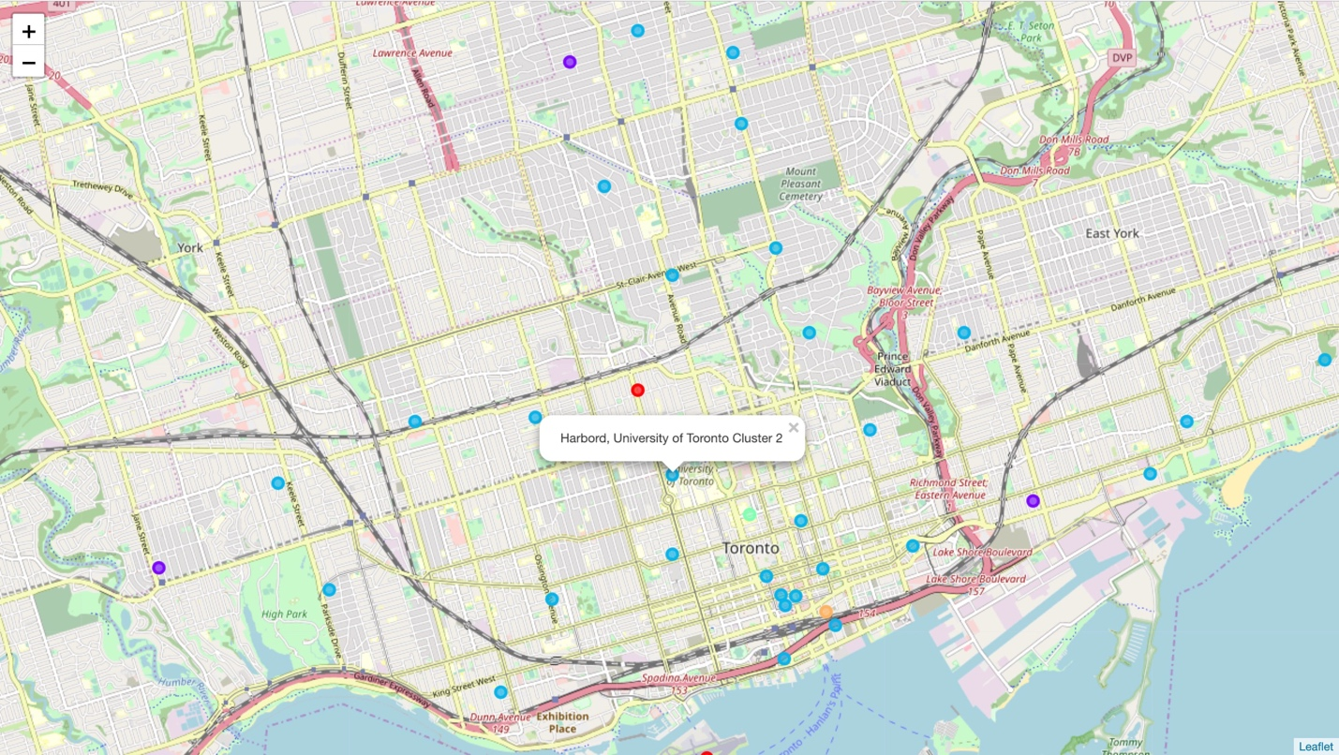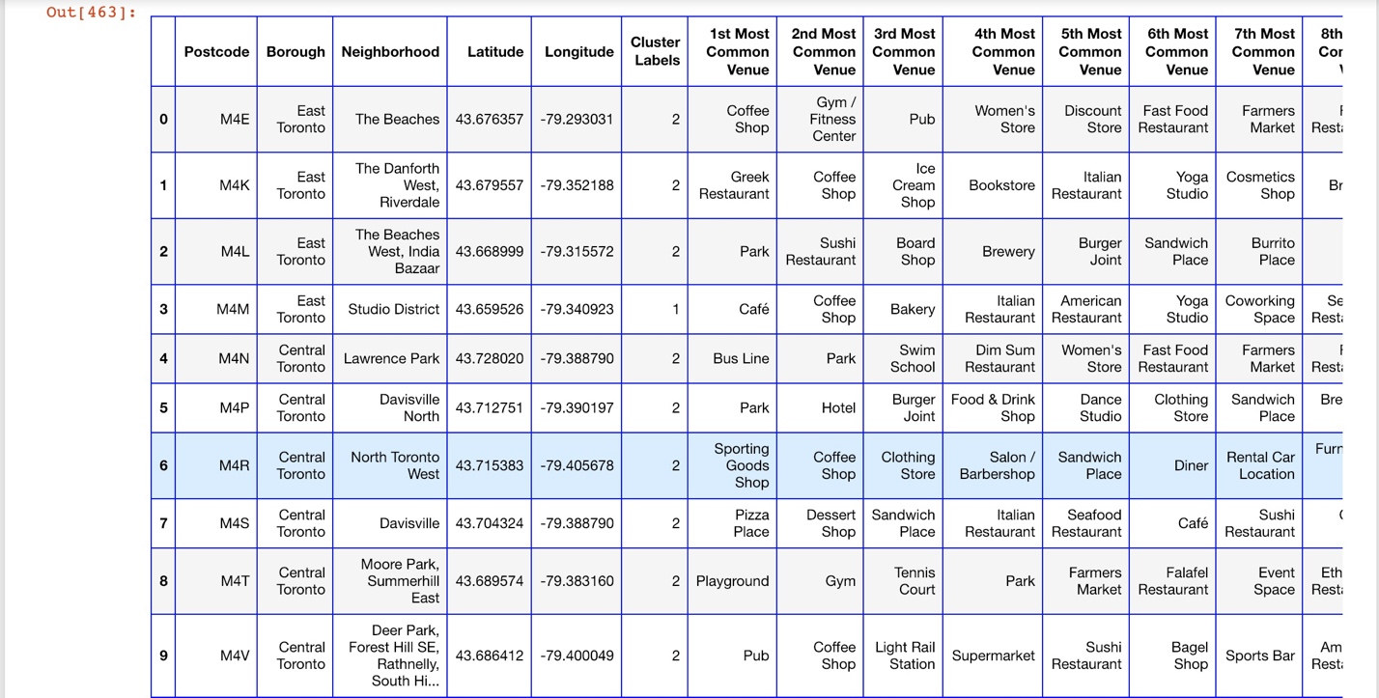Toronto City Popular Neighborhood’s place dataframe and Clusters:

Discussion : For our business problem

1. From cluster and clustering map of Ahmedabad and Toronto**, cluster-3 of Ahmedabad** which also known as **West Ahmedabad** and **cluster-3 of Toronto** are seen like similar in form of Coffey-shop, pizza-Restaurant, Fast-food Restaurant, Café.
2. For Tourism, As per the **Ahmedabad cluster -1** it seems like Tourism place, also there heritage place Delhi Darwaza is situated. It’s also have lake in this cluster And the **Ahmedabad cluster-3** seems like Residential Area.
3. For Toronto no data shown for tourism in clusters, all clusters seems like residential area.
4. For Optimal place for Business, **Ahmedabad cluster-3 and Toronto cluster-3** are seems like good optionfor Business like Coffey-shop, fast-food restaurant, women’s store, boutique, Bookstore, pool, Hotel.
5. From the both cluster of Ahmedabad and Toronto we can say that in Vegetarian ,Mexican, Fast-food ,pizza and Coffey shop are very famous.
6. For Optimal location near Bus-station or Railway station,
   1. In Ahmedabad From the Cluster-4 ,we can say that **Dani lambda and Astodia** are best location. There are no data for Bus-station or Railway station in Toronto City.
7. For Airport Facility,
   1. 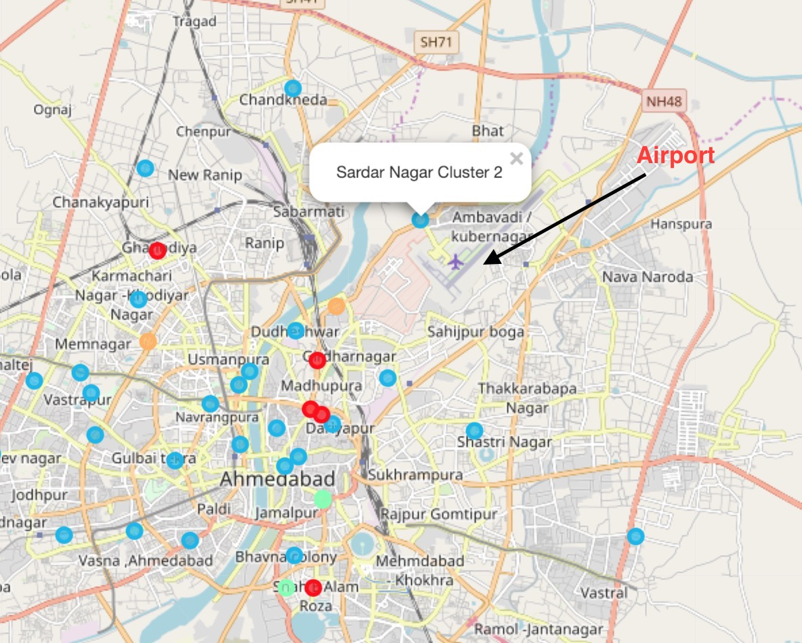In Ahmedabad city, from the **Cluster-2 Ahmedabad** we can say that **Sardar nagar** is near from the **Airport** and Best Option for Hotel Business, because very few hotel around them.
   2. In Toronto City, From the Toronto-City-Cluster 1 we can say that **CN Tower, Bathurst Quay** are best for airport facility, and also airport longue is there.

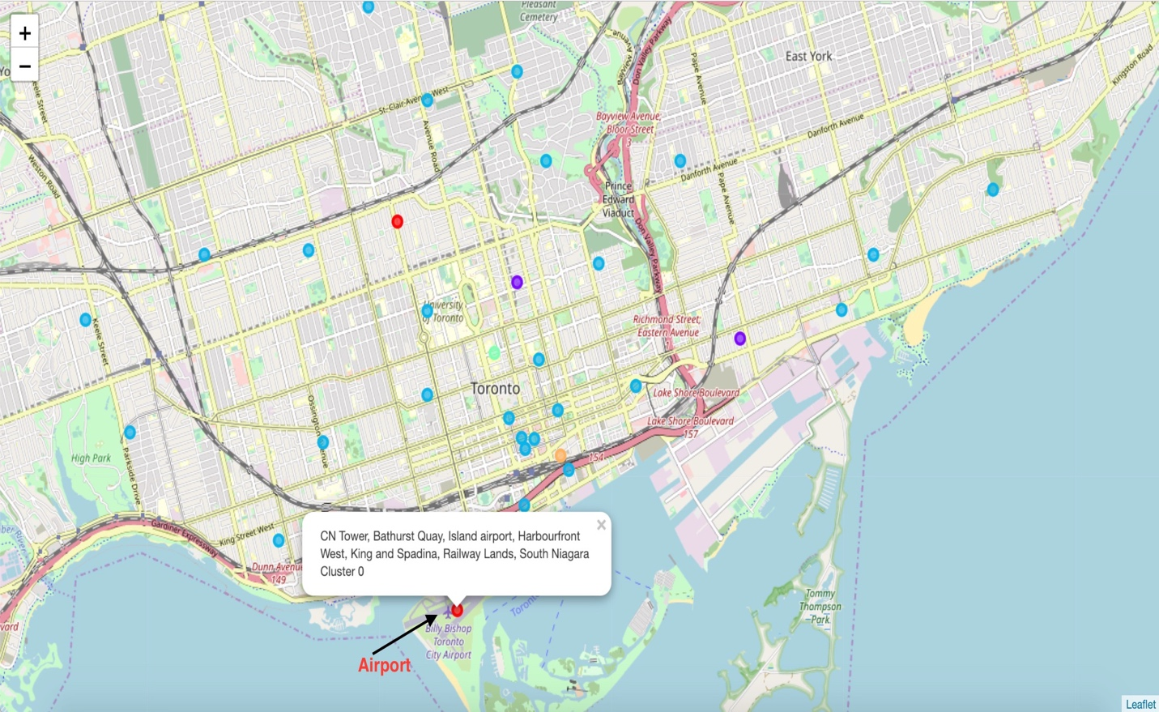

Conclusion

**From the about discussion about our project we can say that,**

* West Ahmedabad is little bit similar like Toronto.
* Ahmedabad have good heritage places and also have Residential Area, and all Toronto area are look like Residential Area.
* Good business option in Ahmedabad and Toronto are Coffey-shop, fast-food restaurant, women’s store, boutique, Bookstore, pool, Café.
* Vegetarian, Mexican, Fast-food, Pizza and Chinese food are famous in Ahmedabad and Canada.
* For Bus and Railway Station Dani lambda and Astodia are optimal location in Ahmedabad.
* For Airport Facility, CN Tower, Bathurst Quay in **Toronto** and Sardar Nagar in **Ahmedabad** are optimal place.
* **We can say that, Both Toronto and Ahmedabad City are optimal place for Business**.

THNAKS FOR READING

BY: MOHIT RAJPUT